**Trading materials**

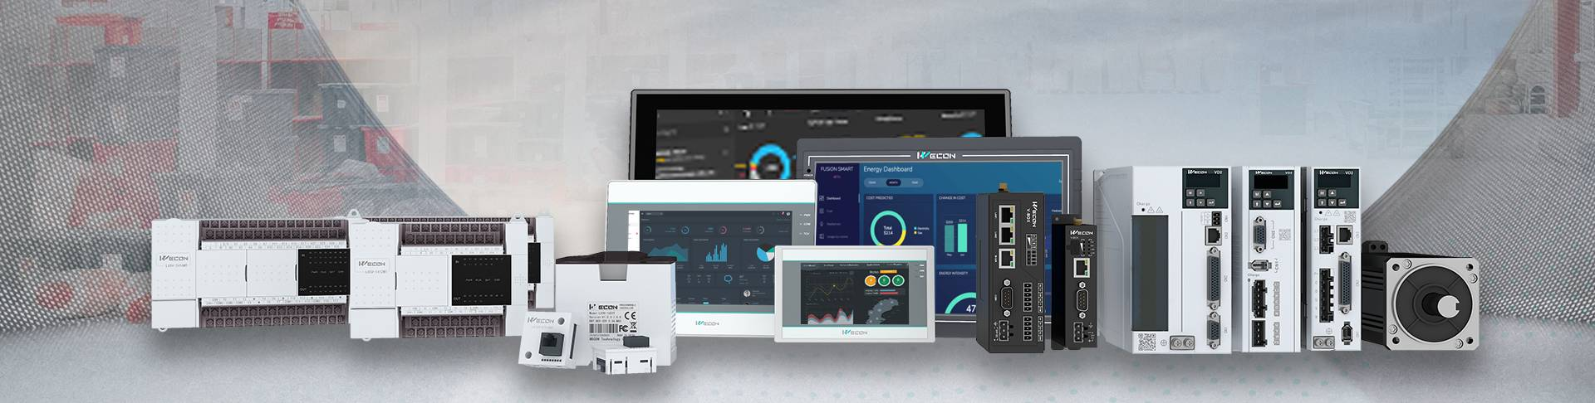

**WECON V-BOX:**

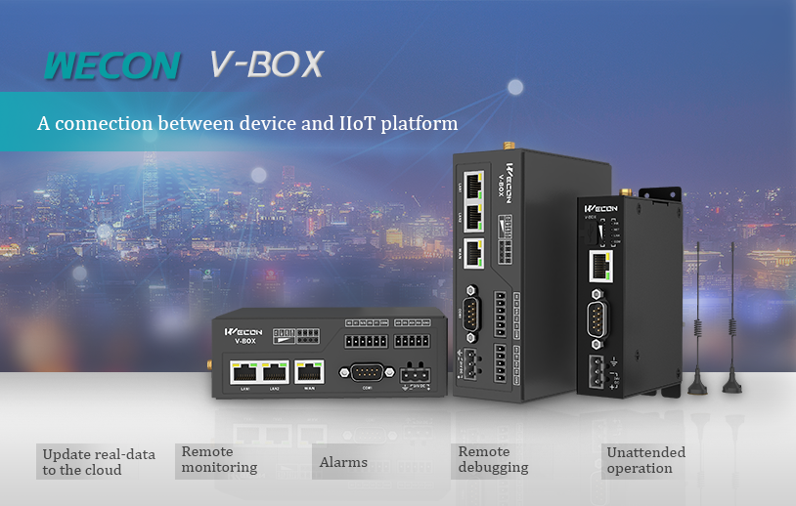

Wecon IIoT Gateway (V-BOX) is the basic hardware of Wecon IIoT platform(V-NET). It is an indispensable equipment about information exchange and protocol conversion for the communication between the IoT cloud platform and the system. V-BOX could define the LUA script to help most machines controlled by PLC to connect with any other cloud platform like HUAWEI, Google IoT, Alibaba Cloud etc. Our website also has HTTPS protocol to ensure the access security of users.

Wecon V-BOX has six series, namely E series, H series,  RE series and RH series. Each series launches models with different specifications according to different market demands. Customers can choose the corresponding V-BOX products according to their own needs.

**WECON SERVO DRIVES:**

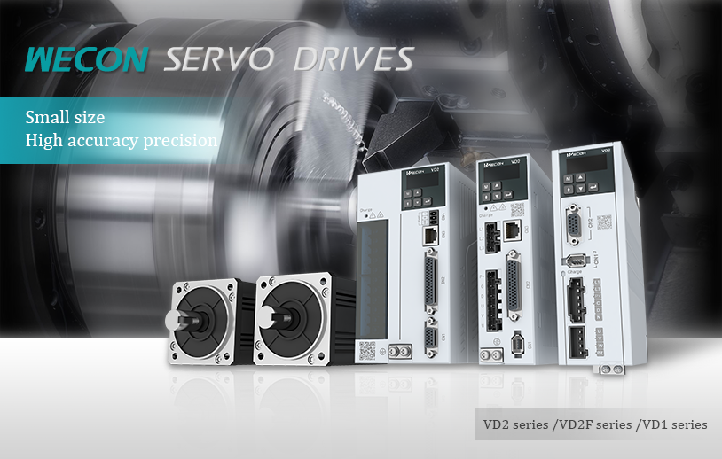

SERVO

Wecon Servo Drives has the features of high response, easy debugging, strong protection etc. It also support virtual I/O function, internal multi-stage speed command, internal multi-stage position command, etc. The products have excellent performance and are widely used.

Wecon Servo’s family has the following members: VD2series, VD2F series and VD2F series.

**WECON PLC:**

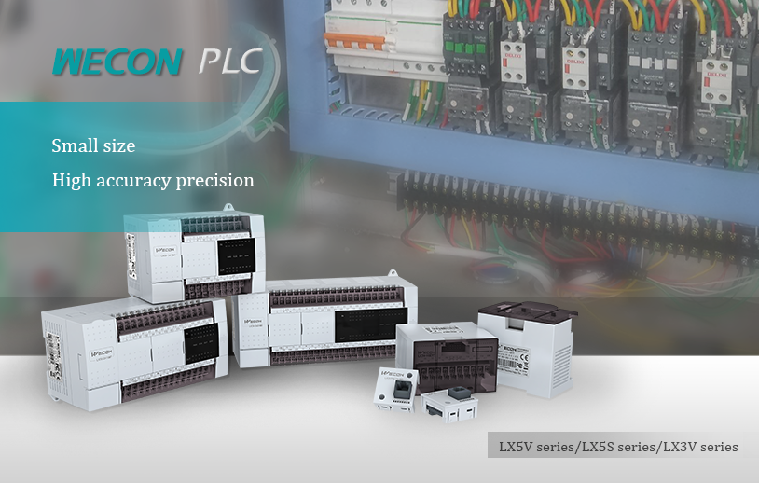

**[PLC](https://www.we-con.com.cn/en/product_s/32.html)**

**[Wecon PLC](https://www.we-con.com.cn/en/product_s/32.html)**[has the features of high precision, fast speed, strong stability etc. In addition to its own various peripheral interfaces, it can also expand various types of expansion modules and expand BD boards to meet different industrial applications. It is widely used in packaging, food, textile, medical, pharmaceutical, environmental protection and other fields .](https://www.we-con.com.cn/en/product_s/32.html)

[Wecon PLC’s family has the following members:](https://www.we-con.com.cn/en/product_s/32.html)**[LX5V series, LX5S series, LX3V series and etc.](https://www.we-con.com.cn/en/product_s/32.html)**

**WECON HMI:**

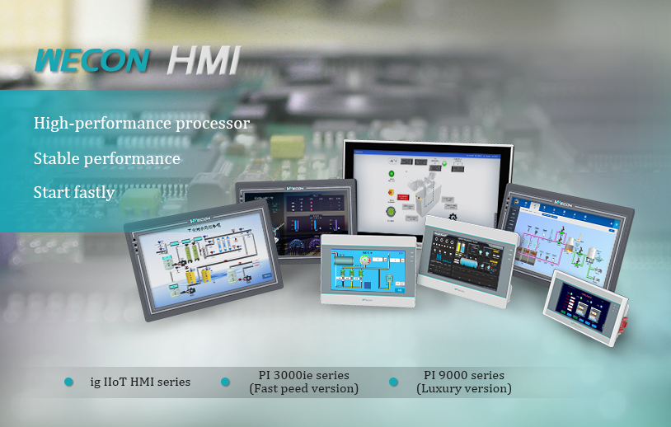

**[HMI](https://www.we-con.com.cn/en/product_s/31.html)**

**[Wecon HMI](https://www.we-con.com.cn/en/product_s/31.html)**[has been widely recognized by the market for economical and practical, fast responcse speed, high configuration, multiple options etc.](https://www.we-con.com.cn/en/product_s/31.html)

**[The PI series HMI](https://www.we-con.com.cn/en/product_s/31.html)**[, the core product of Wecon HMI, has a lot of star products, such as ig IIoT HMI series, Speed version of PI 3000ie series, Luxury version of PI 9000 series etc, all of which have more than the following distinctive functions of installment payment, HMI formula, user authority management and multi-language display to meet the various needs of different users.](https://www.we-con.com.cn/en/product_s/31.html)

**WECON INVERTER:**

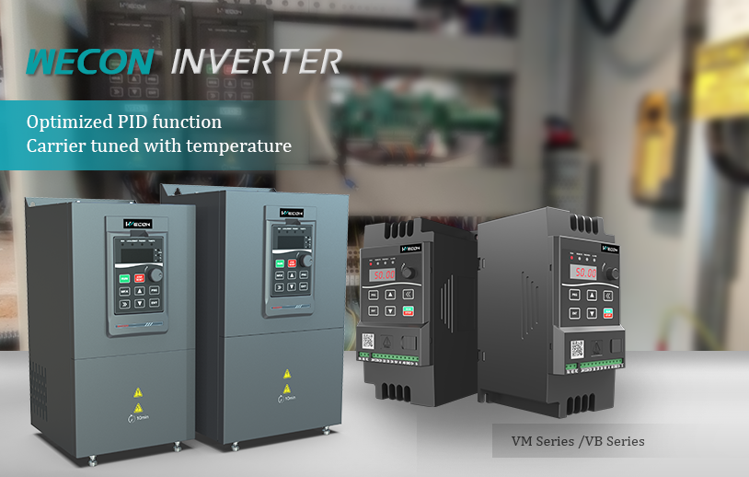

**[INVERTER](https://www.we-con.com.cn/en/product_s/89.html)**

[Independent R&D Product Platform, Outstanding Performance on Various Industrial Automation Control Occasions.](https://www.we-con.com.cn/en/product_s/89.html)

**INDUSTRIAL ETHARNET SWITCH:**

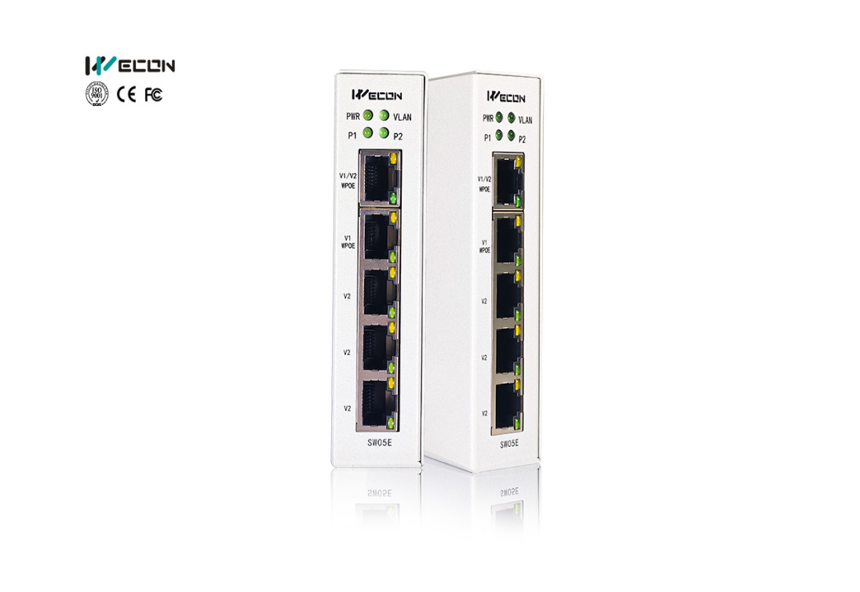

[5 Ethernet Ports](https://www.we-con.com.cn/en/product_t/11308.html)

[Multiple Mounting Options](https://www.we-con.com.cn/en/product_t/11308.html)

[WPoE Function](https://www.we-con.com.cn/en/product_t/11308.html)

[VLAN isolation](https://www.we-con.com.cn/en/product_t/11308.html)

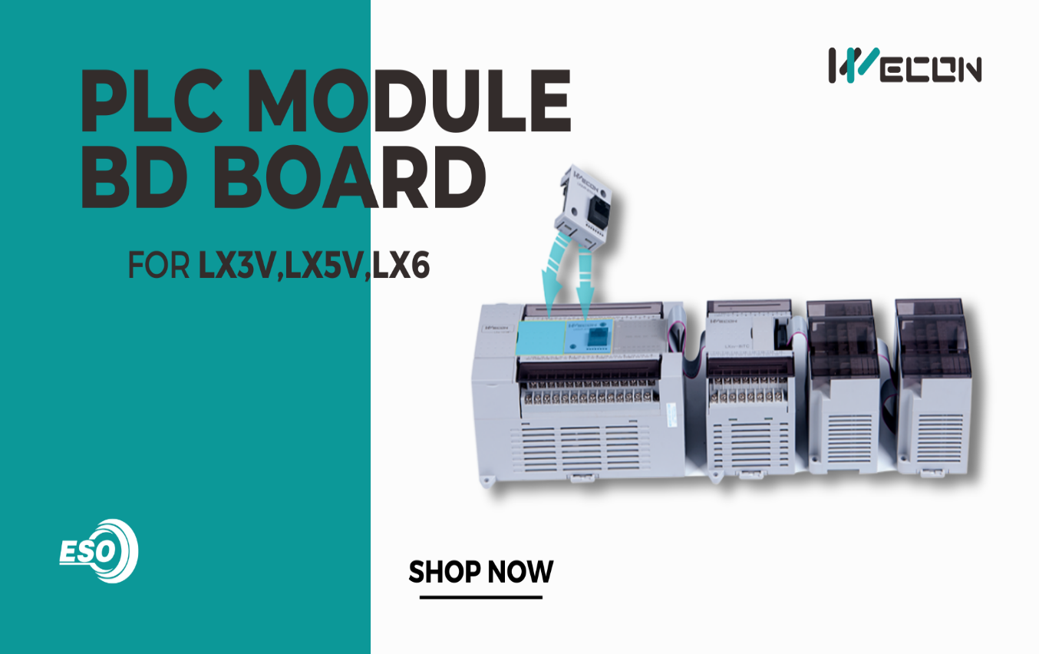

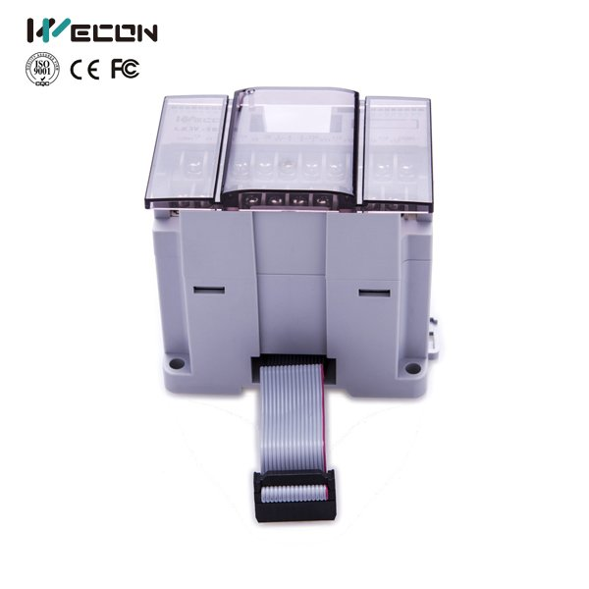

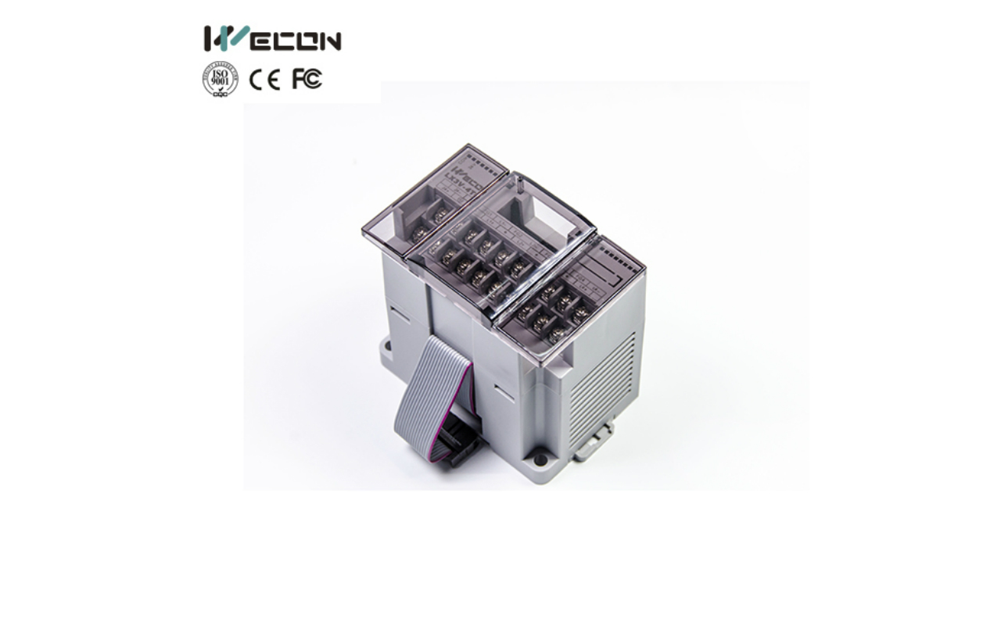



Regd. Office: Global Source Industrial Automation No32, Opp, M.P.M Park,M.P.M Layout,Mallathahalli, Banglore-560056Ph No.+91-7349443674E-Mail: reach.gsia@gmail.com, Web: www.gsia.co.in